Enterprise Infrastructure and Networks – IT-520-A

Mallika Regulla

Marymount University

1. My computers IP address is: 10.0.0.108

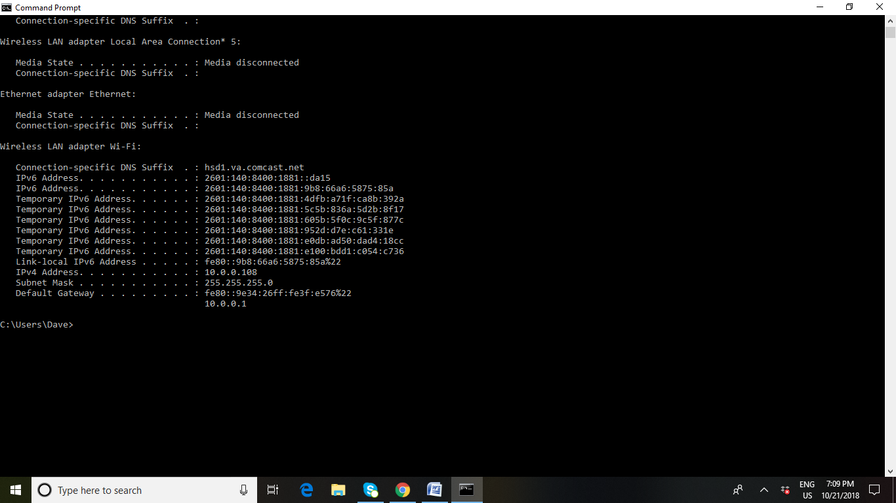

Trace route screenshot

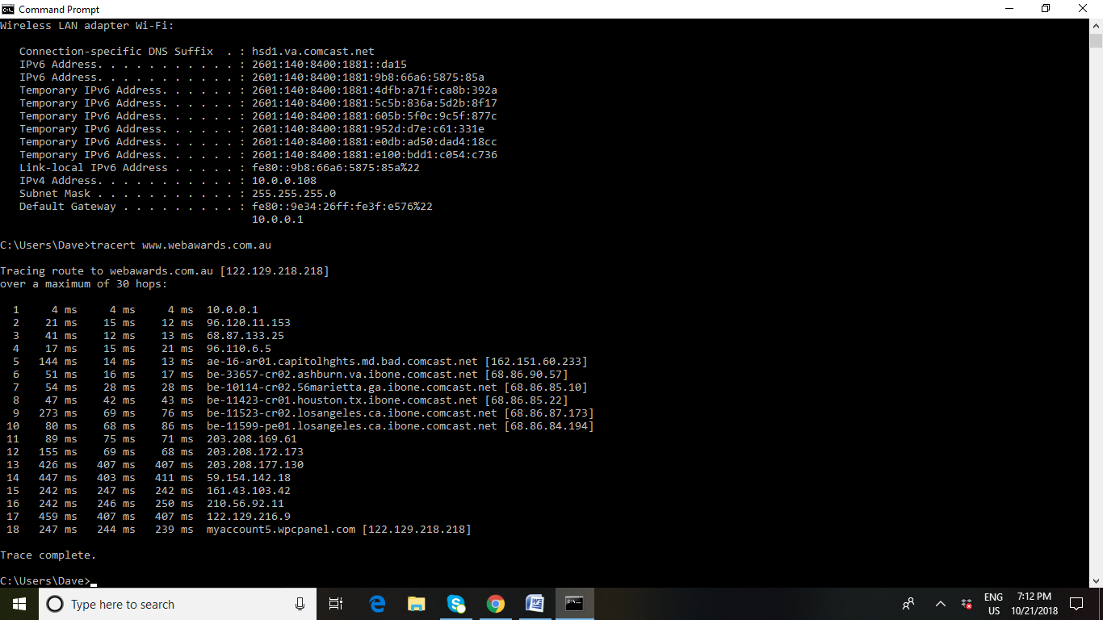

2. The first IP from the trace route result is 10.0.0.1, it is a private IP

3.The second IP from the trace route result is 96.120.11.153, it is a public IP.

4. Tabular representation of the trace route result.

|  |  |  |  |
| --- | --- | --- | --- |
| **Hop Count** | **IP address** | **Organization (IP owner)** | **Location(US state)/Country** |
| 1 | 10.0.0.1 | IANA(Internet assigned numbers authority) | Los Angeles, California state, Country: US |
| 2 | 96.120.11.153 | Comcast IP services, L.L.C | Mt Laurel, New Jersey state, Country: US |
| 3 | 68.87.133.25 | Comcast Cable Communications, Inc | Mt Laurel, New Jersey state, Country: US |
| 4 | 96.110.6.5 | Comcast Cable Communications, L.L.C | Mt Laurel, New Jersey state, Country: US |
| 5 | 162.152.60.233 | Comcast Cable Communications, L.L.C | Mt Laurel, New Jersey state, Country: US |
| 6 | 68.86.90.57 | Comcast Cable Communications, Inc | Mt Laurel, New Jersey state, Country: US |
| 7 | 68.86.85.10 | Comcast Cable Communications, Inc | Mt Laurel, New Jersey state, Country: US |
| 8 | 68.86.85.22 | Comcast Cable Communications, Inc | Mt Laurel, New Jersey state, Country: US |
| 9 | 68.86.27.173 | Comcast Cable Communications, Inc | Mt Laurel, New Jersey state, Country: US |
| 10 | 68.86.84.194 | Comcast Cable Communications, Inc | Mt Laurel, New Jersey state, Country: US |
| 11 | 203.208.169.61 | Singapore Telecommunications(SINGTEL Internet exchange) | Country: Singapore |
| 12 | 203.208.172.173 | Singapore telecommunications Pte.ltd | Country: Singapore |
| 13 | 203.208.177.130 | Singapore telecommunications Pte.ltd | Country: Singapore |
| 14 | 59.154.142.18 | SingTel Optus Pty Ltd | Country: Australia |
| 15 | 161.43.103.42 | SingTel Optus Pty Ltd | Country: Australia |
| 16 | 210.56.92.11 | Escape Net | Melbourne, Country: Australia |
| 17 | 122.129.216.9 | Web Prophets Pty Ltd | Country: Australia |
| 18 | 122.129.218.218 | Web Prophets Pty Ltd | Country: Australia |

5. Here by using the trace router we tracked the pathway taken by a packet taken by a packet on an IP network from source to destination. From the trace route results that we got, it is evident that the packet took 18 hops for reaching the destination from the source. From the source the packet has travelled along two states in US, first to California (Los Angeles) then to New Jersey (Mt Laurel). And it has travelled along two countries other than US, first along Singapore then through Australia.